System Requirements Statement (SRS) –

Online Art Gallery

Doc. Ref. :

Version : 0.4

Status : Drafted

Created by : Pooja Bolkar.

Ashwini Mule.

Omkar Ganjave.

Prajwal Patil.

Date : 31-july-2022

1. Introduction 3

2. Functional Requirements 4

2.1 Artist Module 5

2.2 Customer Module 11

2.3 admin Module 17

2.4 message acknoeledgement Module 21

2.5 Use Case Diagram.............................................................................................................................22

THIS DOCUMENT CONTAINS 23 NUMBERED PAGES

# Introduction

This document explains the system requirements and scope for developing Online Art Gallery.

Online Art Gallery could divide the four main parts, Artist part, Customer part, Admin part and the acknowledgement part.

This document describes the system requirement of the Account part.

****/other information req?….****

# Functional Requirements

The Account part of Online Art Gallery System has three modules which are divided 13 processes described as below.

|  |  |  |
| --- | --- | --- |
| **No** | **BRS requirement ID** | **Description** |
| **2.1** | **Artist Module** | |
| **2.1.1** | **F1** | **Account Creation Process** |
| **2.1.2** | **F2** | **Login Process** |
| **2.1.3** | **F3** | **Forgot Password Process** |
| **2.1.4** | **F4** | **Change Password Process** |
| **2.1.5** | **F5** | **Update Account Process** |
| **2.1.6** | **F6** | **Search Product** |
| **2.1.7** | **F7** | **Publish Product for sale** |
| **2.1.8** | **F8** | **Update Product Information** |
| **2.1.9** | **F9** | **Delete Product** |
| **2.2** | **Customer Module** | |
| **2.2.1** | **F11** | **Account Creation Process** |
| **2.2.2** | **F12** | **Login Process** |
| **2.2.3** | **F13** | **Forgot Password Process** |
| **2.2.4** | **F14** | **Change Password Process** |
| **2.2.5** | **F15** | **Update Account Process** |
| **2.2.6** | **F16** | **Search Product** |
| **2.2.7** | **F17** | **Buy Products** |
| **2.2.8** | **F18** | **Payback Process** |
| **2.2.9** | **F19** | **Cancel Order** |
| **2.3 Admin Module** | | |
| **2.3.1** | **F21** | **Login Process** |
| **2.3.2** | **F22** | **Forgot Password Process** |
| **2.3.3** | **F23** | **Change Password Process** |
| **2.3.4** | **F24** | **Update Account Process** |
| **2.3.5** | **F25** | **Report Generation** |
| **2.3.6** | **F26** | **Account Management** |
| **2.4 Message Acknowledgement Module** | | |
| **2.4.1** | **F27** | **Sends Messages of Acknowledgement** |

## Artist Module

* Artist is the user of system who wants to sale the product.

* He is also able to view the market prices of products.

### Account Creation Process

* Online Art Gallery System compels to create the account before using it. So, Online Art Gallery System should provide the function which makes Artist creates new account.
* When artist creates new account, the function demands for information described as below.

1. Login information
2. Contact Details

* The Login information

The Login information consists of some items described as below.

1. ArtistID
2. Password
3. First Name
4. Last Name
5. E-mail address
6. User Type
   * All items are compulsory demanded.

* ArtistID

The ArtistID should be unique. If the ArtistID correspond with not case-sensitive to other which is previously registered, the ArtistID should not be registered as an account.

* + Password
* The Password has constrains which makes the Password consists of more than or equal 8 and less than or equal 16 characteristics including characters described as below.

1. Numeric figure (at least one)
2. Capital alphabet (A-Z)(at least one)
3. Small alphabet (a-z)(at least one)
4. Special character (#, $, %, &, etc.) (at least one)

* The Password is masked by dummy characters. The re-entering Password is demanded.
* The Password must be encrypted in Online Art Gallery System.
  + User Type

The User Type falls into three categories described as below.

1. Artist
2. Customer
3. Administrator

* The User Type defines also three types of user; "Artist user", "Customer user", and "Administrator user”.
* Account Creation Process.
* No one could select The Administrator, because Administrator is implemented to Online Art Gallery System in advance.
* Contact Details
* The Contact Detail consists of some items described as below.

1. Permanent Address
2. Contact Phone No
   * All items are compulsory demanded.
   * Permanent Address

* Permanent Address should be filled.
* But only the state should be selected from options.
* The Security Question information

The Security Question information is needed when artist lost their Password. This information consists of two items described as below.

1. Selected Question
2. Answer
   * All items are compulsory demanded.
   * Some questions which are difficult to answer for anyone else are prepared in advance.

E.g. which color do you like most?

* + A question should be selected from options by the artist, and the Answer is registered by the artist.
* Login information should be entered on one screen, and then artist information and Security Question information should be entered on another screen.

### Login Process

* Online art Gallery System always compels Artist authentication before using itself except when a new account is successfully created.
* The Artist authentication demands ArtistID and Password. The ArtistID and the Password should be checked in three ways.
  + First, The ArtistID and the Password should be existed and correct.
* If The ArtistID and the Password are not equal to what the artist has registered, the artist authentication cannot be provided.
  + Second, the User Type linked to the ArtistID should be "artist".
* When the User Type is "Artist", then user can be placed on “Artist Home”.
  + Finally, ArtistID should be available.
* The Administrator can decide whether the ArtistID is available or suspended – Refer to the SRS of the Admin part.
* If artist is rejected, artist authentication is not provided for system user.
* The artist account should alive for so long as the duration decided by Admin.
* Only when the three checks are successfully completed, artist can be placed on respected page.
* The “Artist Home” provides the some items described as below.

1. A trigger to logout
2. A trigger to update Account
3. A trigger to Change Password
4. A trigger to Search Product
5. A trigger to Publish Product for sale
6. A trigger to Update Product Information
7. A trigger to Delete Product

### Forgot Password Process

* When system artist lost their Password, the recovery method should be provided by Online Art Gallery system.

The recovery method is described as below.

* + First, Artist enters their ArtistID for Online Art Gallery System.
  + Next, Online art Gallery System demands the Answer which has been registered since when the Account was created.
  + Only when the Answer is correct, artist get the new password by E-mail which also has been registered since when the Account was created.
  + The new password is automatically generated by Online Art Gallery System.
* Of course, the new password should consist of more than or equal 8 and less than or equal 16 characteristics including at least a numeric figure, a capital alphabet, a small alphabet, and a special character.
* As a consequence, The Artist could get the authentication using the new password.
  + Then, the artist had better change the new password manually.
* If the Answer is not correct, otherwise, the correct Answer is demanded for user again.
  + In that case, Of course, artist couldn’t get the new password.

### Change Password Process

* When artist wants to change their Password, the measure should be provided by Online Art Gallery System.
* Therefore, Online Art Gallery System should provide the function which is available after getting the artist authentication.
* The function demands the current password and the new password.
  + Of course, the new password should consist of more than or equal 8 and less than or equal 16 characteristics including at least a numeric figure, a capital alphabet, a small alphabet, and a special character.
  + The current password and the new password are masked by using dummy characters.
  + The new password is demanded to enter twice to avoid a typing error.
* Only when the current password is correct, artist could change their Password.
* When the current password is changed into new password, Online Art Gallery System compels artist authentication again.

### Update Account Process

* Online Art Gallery System should provide the function which makes the account updated for artist.
* The information artist could update is described below.

1. Login information
2. Artist information
3. Security Question Information

* The Login information

The updatable items as described below.

1. First Name
2. Last Name
3. E-mail address
   * All items are compulsory demanded, but updating is optional.

* The Artist information

The updatable items as described below.

1. Artist Name
2. Artist Phone No
3. E-mail address
4. Permanent address
   * All items are compulsory demanded, but updating is optional.

* The Security Question information

The updatable items as described below.

1. Selected Question
2. Answer
   * All items are compulsory demanded, but updating is optional.

### Search product

* Search conditions are described as below.

1. Product category
2. Price range

### Publish product for sale

* Publish products requirements are described as below.

1. Product category
2. Price
3. Product name
4. Quantity
5. Photos

### Update product information

* After publishing the product the artist can only update following contents.

1. Product quantity
2. Product price.

### Delete product information

• After Publishing if artist wants to remove some products then he can delete the product.

#### Customer Module

### Account Creation Process

* Online Art Gallery System compels to create the account before using it. So, Online Art Gallery System should provide the function which makes customer creates new account.
* When customer creates new account, the function demands for information described as below.

1. Login information

2. Contact Details

3. Security Question Information

4. Payment information.

* The Login information

The Login information consists of some items described as below.

5. CustomerID

6. Password

7. First Name

8. Last Name

9. E-mail address

10. User Type

* + All items are compulsory demanded.
* CustomerID

The CustomerID should be unique. If the CustomerID correspond with not case-sensitive to other which is previously registered, the CustomerID should not be registered as an account.

* + Password
* The Password has constrains which makes the Password consists of more than or equal 8 and less than or equal 16 characteristics including characters described as below.

1. Numeric figure (at least one)

2. Capital alphabet (A-Z)(at least one)

3. Small alphabet (a-z)(at least one)

4. Special character (#, $, %, &, etc.) (at least one)

* The Password is masked by dummy characters. The re-entering Password is demanded.
* The Password must be encrypted in Online Art Gallery System.
  + User Type

The User Type falls into three categories described as below.

1. Artist

2. Customer

3. Administrator

* The User Type defines also three types of user; "Artist user", "Customer user", and "Administrator user”.
* Account Creation Process.
* No one could select The Administrator, because Administrator is implemented to Online Art Gallery System in advance.
* Contact Details
* The Contact Detail consists of some items described as below.

1. Permanent Address

2. Contact Phone No

* + All items are compulsory demanded.
  + Permanent Address
* Permanent Address should be filled.
* But only the state should be selected from options.
* The Security Question information

The Security Question information is needed when Customer lost their Password. This information consists of two items described as below.

1. Selected Question
2. Answer
   * All items are compulsory demanded.
   * Some questions which are difficult to answer for anyone else are prepared in advance.

E.g. which color do you like most?

* + A question should be selected from options by the Customer, and the Answer is registered by the Customer.
* Login information should be entered on one screen, and then Customer information and Security Question information should be entered on another screen.

### Login Process

* Online Art Gallery System always compels Customer authentication before using itself except when a new account is successfully created.
* The Customer authentication demands CustomerID and Password. The CustomerID and the Password should be checked in three ways.
  + First, The CustomerID and the Password should be existed and correct.
* If The CustomerID and the Password are not equal to what the customer has registered, the customer authentication cannot be provided.
  + Second, the User Type linked to the CustomerID should be "Customer".
* When the User Type is "Customer ", user can be placed on “Customer Home”.
  + Finally, CustomerID should be available.
* The Administrator can decide whether the CustomerID is available or suspended – Refer to the SRS of the Admin part.
* If customer is rejected, customer authentication is not provided for Customer.
* The Customer account should alive for so long as the duration decided by Admin.
* Only when the three checks are successfully completed, Customer can be placed on respected page.
* The “Customer Home” provides the some items described as below.

1. A trigger to logout
2. A trigger to update Account
3. A trigger to Change Password
4. A trigger to Search Product
5. A trigger to Publish Product for sale
6. A trigger to Update Product Information
7. A trigger to Delete Product

### Forgot Password Process

* When Customer lost their Password, the recovery method should be provided by Online Art Gallery system.

The recovery method is described as below.

* + First, Customer enters their CustomerID for Online Art Gallery System.
  + Next, Online Art Gallery System demands the Answer which has been registered since when the Account was created.
  + Only when the Answer is correct, Customer get the new password by E-mail which also has been registered since when the Account was created.
  + The new password is automatically generated by Online Art Gallery System.
* Of course, the new password should consist of more than or equal 8 and less than or equal 16 characteristics including at least a numeric figure, a capital alphabet, a small alphabet, and a special character.
* As a consequence, The Customer could get the Customer authentication using the new password.
  + Then, the Customer had better change the new password manually.
* If the Answer is not correct, otherwise, the correct Answer is demanded for Customer again.
  + In that case, Of course, Customer couldn’t get the new password.

### Change Password Process

* When Customer wants to change their Password, the measure should be provided by Online Art Gallery System.
* Therefore, Online Art Gallery System should provide the function which is available after getting the Customer authentication.
* The function demands the current password and the new password.
  + Of course, the new password should consist of more than or equal 8 and less than or equal 16 characteristics including at least a numeric figure, a capital alphabet, a small alphabet, and a special character.
  + The current password and the new password are masked by using dummy characters.
  + The new password is demanded to enter twice to avoid a typing error.
* Only when the current password is correct, Customer could change their Password.
* When the current password is changed into new password, Online Art Gallery System compels Customer authentication again.

### Update Account Process

* Online Art Gallery System should provide the function which makes the account updated for Customer.
* The information Customer could update is described below.

1. Login information

2. Customer information

3. Security Question Information

* The Login information

The updatable items as described below.

1. First Name
2. Last Name
3. E-mail address
   * All items are compulsory demanded, but updating is optional.

* The Customer information

The updatable items as described below.

1. Customer Name
2. Customer Phone No
3. E-mail address
4. Permanent address
   * All items are compulsory demanded, but updating is optional.

* The Security Question information

The updatable items as described below.

1. Selected Question
2. Answer
   * All items are compulsory demanded, but updating is optional.

#### Search Product

• Search conditions are described as below.

1. Product category

2. Price range

• As the result of searching Requirements, Customer could see the list of products which are available for sale.

1. Product name

2. Price

3. Quantity

4. Photos

#### Buy Product

• To buy the product followings are the condition

1. Product category

2. Price range

3. Product Quantity

4. Product Name

**2.2.8 Payback Process**

• In payback process system following are the conditions

1. If somehow order is not fulfil.

2. If Customer is not satisfied with product.

**2.2.9 Cancel Order**

• Before paying Customer can cancel the order in following condition

1. If the product does not fulfil the requirement.

2. If price goes out of his budget.

#### Admin Module

**•** Administratorshould be responsible for following activities**,**

### Login Process

* Online Art Gallery System always compels Admin authentication before using itself except when a new account is successfully created.
* The Admin authentication demands AdminID and Password. The AdminID and the Password should be checked in three ways.
  + First, The AdminID and the Password should be existed and correct.
* If The AdminID and the Password are not equal to what the admin has registered, the Admin authentication cannot be provided.
  + Second, the User Type linked to the AdminID should be "Admin".
* When the User Type is "Admin", user can be placed on “Admin Home”.
  + Finally, AdminID should be available.
* The Administrator can decide whether the AdminID is available or suspended – Refer to the SRS of the Admin part.
* If Admin is rejected, Admin authentication is not provided for system user.
* The Admin account should alive for so long as the duration decided by system user.
* Only when the three checks are successfully completed, Admin can be placed on respected page.
* The “Admin Home” provides the some items described as below.

1. A trigger to logout
2. A trigger to update Account
3. A trigger to Change Password
4. A trigger to Search Product
5. A trigger to Publish Product for sale
6. A trigger to Update Product Information
7. A trigger to Delete Product

### Forgot Password Process

* When Admin lost their Password, the recovery method should be provided by Online Art Gallery system.

The recovery method is described as below.

* + First, Admin enters their AdminID for Online Art Gallery System.
  + He will enter the E-mail id since when the Account was created.
  + Only when the E-mail Id is correct, Admin get the new password by E-mail which also has been registered since when the Account was created.
  + The new password is automatically generated by Online Art Gallery System.
* Of course, the new password should consist of more than or equal 8 and less than or equal 16 characteristics including at least a numeric figure, a capital alphabet, a small alphabet, and a special character.
* As a consequence, The Admin could get the Admin authentication using the new password.
  + Then, the Admin had better change the new password manually.

### Change Password Process

* When Admin wants to change his Password, the measure should be provided by Online Art Gallery System.
* Therefore, Online Art Gallery System should provide the function which is available after getting the Admin authentication.
* The function demands the current password and the new password.
  + Of course, the new password should consist of more than or equal 8 and less than or equal 16 characteristics including at least a numeric figure, a capital alphabet, a small alphabet, and a special character.
  + The current password and the new password are masked by using dummy characters.
  + The new password is demanded to enter twice to avoid a typing error.
* Only when the current password is correct, Admin could change his Password.
* When the current password is changed into new password, Online Art Gallery System compels Admin authentication again.

### Update Account Process

* Online Art Gallery System should provide the function which makes the account updated for Admin.
* The information Admin could update is described below.

1. Login information
2. Admin information
3. Security Question Information

* The Login information

The updatable items as described below.

1. First Name
2. Last Name
3. E-mail address
   * All items are compulsory demanded, but updating is optional.

* The Admin information

The updatable items as described below.

1. Admin Name
2. Admin Phone No
3. E-mail address
4. Permanent address
   * All items are compulsory demanded, but updating is optional.

* The Security Question information

The updatable items as described below.

1. Selected Question
2. Answer
   * All items are compulsory demanded, but updating is optional.

#### Record Generation

• Admin should able to see all the records from any users.

• Daily report of enrolment to admin.

• Monthly report of enrolment as per the states to admin.

#### Accounts Management

• Admin should able to manage all the accounts with following activities,

1. Enable accounts

2. Disable accounts

#### Message Acknowledgement Module*

• In following conditions acknowledgement to be send

1. After completion of successful registration.
2. After every successful transaction (buy, sale).
3. Now the messages are being sent by using email but in future we can have mobile sms.

#### 2.5 Use Case Diagram

**Admin:**

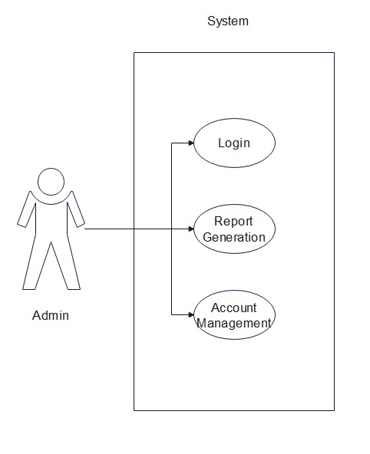

*Fig. Use case diagram for admin*

1. In Admin use case diagram Admin is the Actor.
2. Admin can handle following use cases:
3. Login
4. Report Generation
5. Controls account

**Artist:**

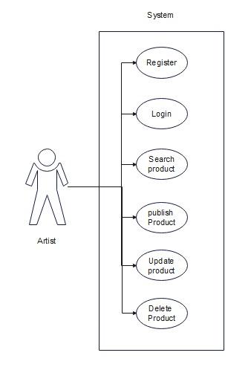

*Fig. Use case diagram for Artist*

1. In Artist use case diagram Artist is the Actor.
2. Artist can handle following use cases:
3. Register
4. Login
5. Search Product
6. Publish Product
7. Update Product
8. Delete Product

**Customer:**

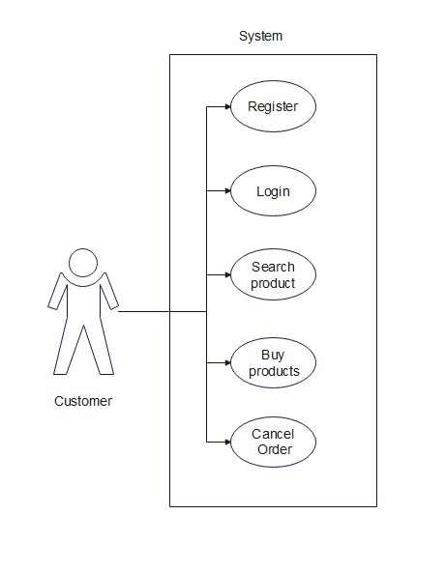

*Fig. Use case diagram for Customer*

1. In Customer use case diagram Customer is the Actor**.**
2. Customer can handle following use cases:
3. Register
4. Login
5. Search Product
6. Buy Product
7. Payback
8. Cancel Order